Pop culture has become a powerful tool in a marketer's arsenal. By incorporating trending topics, memes, or references from popular movies, TV shows, or music, brands can instantly capture attention and connect with their audience on a deeper level. This creates a sense of shared experience and makes the brand feel more relatable and relevant. Imagine a sneaker commercial featuring a popular dance move from a viral TikTok video. It instantly grabs attention and positions the brand as being in tune with current trends.

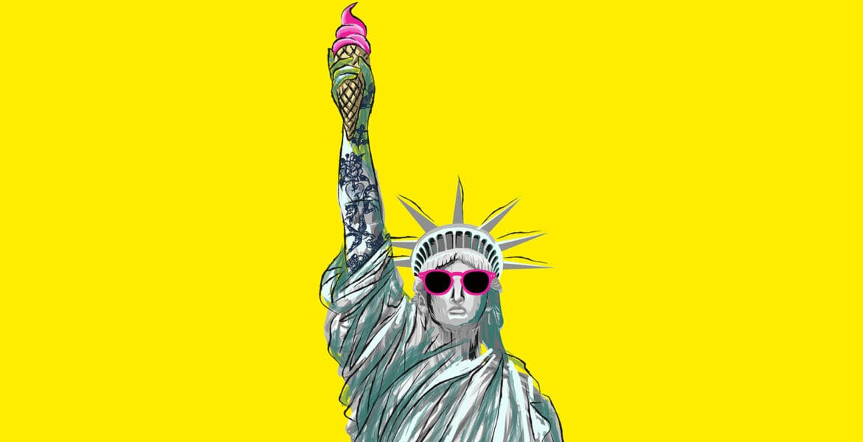

The key to successful pop culture marketing lies in authenticity. Consumers can sniff out a forced reference a mile away. The chosen element should resonate with the brand's values and target audience. A sports apparel brand partnering with a famous athlete for a campaign makes perfect sense, but the same collaboration wouldn't work for a company selling high-end jewelry.

Pop culture can also be a double-edged sword. Trends move fast, and what's hot today can be forgotten tomorrow. Marketers need to be nimble and stay on top of the latest happenings. Additionally, a poorly timed or insensitive reference can backfire spectacularly. Careful planning and execution are crucial to ensure a pop culture campaign lands successfully.